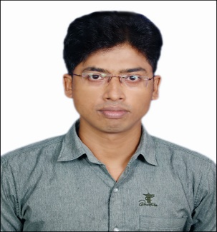
Tufan Nandi
.Net Developer in ITOrbital
nanditufanfiem@gmail.com
+91-9681151657
DOB: 16th May, 1989

6.2 years of software development experience in information Technology and services industry
Experience Summary
- Hands on experience in developing web application using ASP.NET, C#, MVC and SQL Server.
- Experience in Web technologies like WCF and REST Services
- Experience in creating rich content like Web-Forms, Web User Controls and Web Service.
- Experience in cloud environment AWS, Google, Azure, VCloud air, Profitbricks, SoftLayer, Oracle, CenturyLink
- Experience in web-based page and site designs using JQuery, AJAX and Angular JS
- Basic knowledge of Entity framework
- Good Working experience of JIRA Tool
- Experience with Data Accessing using ADO.NET and LINQ (Language Integrated Query)
- Experience in handling SLA based tickets and resolving them within stipulated time and providing regular status updates to client. Worked on stringent timelines to resolve issues and close them with proper update.
- Work closely with other Programmer/Analysts to deliver timely and cost-effective solutions.
- Good knowledge of OOPS (Object Oriented Programming Structure).
- Knowledge of versioning tools like TFS (Team Foundation Server), GIT and SVN
- Sound knowledge of Stored Procedures, Functions, Views, Triggers in Database Design.
- Experience in software unit testing and efficient at fact-finding, root cause analysis and bug fixing.
- Very good Team player, Self-motivated, hardworking professional with good organizational, leadership, interpersonal and communication skills.
Work Experience
- Company Name: ITOrbital
Span: 9th June 2020-31st Aug,2021
Duration: 1 Year 3 months
Designation: Software developer

- Company Name: Infosys Limited
Span: 11th September 2017-30th December,2019
Duration: 2 years 4 months
Designation: Senior system Engineer

- Company Name: Genx Technology Services
Span: 17th November 2014 – 31st August 2017
Duration: 2 years 9 months (+)
Designation: Consultant
Training and Certification
- Organization Name: NIVT Industrial Training Centre (National Council of Vocational Training)
Span: June-July 2010
Duration: 2 months
Certified Name: Summer Internship
Topic Covered: ASP.Net (C#) and SQL Server

- Organization Name: CMC Limited
Span: 3rd Nov 2011 – 29th Feb 2012
Duration: 3 months
Certified Name: CMC job enabled Training
Topic Covered: Programming Languages, DBMS, SDLC, and soft skill
Academic Qualification
Sl. | Degree | Board / Univ. | Marks (Year of Passing) | Major and Specialization
1. | B. Tech. | WBUT | 81.4%(2011) | Information Technology
2. | Higher Secondary | WBCHSE | 74% (2007) | Science
3. | Secondary Examination | WBBSE | 83% (2005) | Science, Bengali, Eng. Mathematics
Technical Skill
- Development Tool: Visual studio 2013/2017
- Database: SQL Server 2008/2012(Stored procedure, function, Trigger, Views)
- Web Technology: ASP.NET(C#), MVC, WCF, Web services, LINQ, JavaScript, jQuery, Telerik for UI and Angular JS
- Cloud Technology: AWS, Google, Azure, VCloud air, Profitbricks, Softlayer, Oracle, Centurylink
- Services: Web service, WCF
- Source Control: TFS, GIT
Projects

1. e-Vidhan-Arunachal Pradesh | Organization | ITOrbital
1. e-Vidhan-Arunachal Pradesh | Project Description | - The e- Vidhan is a system to automate the processes involved in working of Legislative Assembly and its Secretariat including working of various House Committees and managing respective Constituencies by Hon’ble Members.  - Enhancement or modification in e- Vidhan portal along with functional task like providing excel documentation report to clients from the database
1. e-Vidhan-Arunachal Pradesh | Technologies/  Environment | .Net Framework 4.0, Angular JS, SQL Server 2014  Visual Studio 2015,
1. e-Vidhan-Arunachal Pradesh | Client | Arunachal Pradesh Govt.
1. e-Vidhan-Arunachal Pradesh | Role | Development and maintenance
1. e-Vidhan-Arunachal Pradesh | Team Size | 7
1. e-Vidhan-Arunachal Pradesh | Responsibility | My responsibility was to develop UI, consuming services to show data and saving information from UI to database Sometimes worked on the Enhancement and UI fixes as well

1. PWC stars Support and Enhancement | Organization | Infosys Limited
1. PWC stars Support and Enhancement | Project Description | - The website is responsible for maintaining the tax pay to government, if more has been paid then how to compensate that for any legal entity or sub entity and provide report.  - Enhancement or modification in the star’s tax portal along with functional task like providing excel documentation report to US clients from the database
1. PWC stars Support and Enhancement | Technologies/  Environment | .Net Framework 4.0, MVC, Angular JS, SQL Server 2014  Visual Studio 2015, Entity Framework
1. PWC stars Support and Enhancement | Client | PWC
1. PWC stars Support and Enhancement | Role | Maintenance and Support
1. PWC stars Support and Enhancement | Team Size | 6
1. PWC stars Support and Enhancement | Responsibility | My responsibility was to give functional support to the clients or some documentation work for the client if any or  Sometimes worked on the Enhancement and UI fixes as well

2. Handling SLA Based JIRA Ticket of Analog Device(US Client) | Organization | Infosys Limited
 | Project Description | - The website was responsible for marketing the various analog product like chips to the customer also if any new product comes advertising the product in the portal.  - Handling SLA based tickets and resolving them within stipulated time and providing regular status updates to client
 | Technologies/  Environment | .Net Framework 4.0, MVC, Sitecore, Visual Studio 2013, SQL Server 2008, C#
 | Client | Analog Devices
 | Role | Maintenance and Support
 | Team Size | 26
 | Responsibility | Analog Devices: UI issue fixes, Enhancement resolve issues within stringent timelines and close them with proper update.

3. ATASphere (Web Application) | Organization | Genx Technology Services
3. ATASphere (Web Application) | Description | The purpose of the product is to migrate a system, a network among the platforms in cloud. Firstly, this scans a system or all the systems of entire network and collects all the information to specify which type of migration is required and the other details, then creates target system in the specified platform after that migrate all the data of source system to target system then syncing started if required.
3. ATASphere (Web Application) | Technologies/  Environment | .Net Framework 4.0, LINQ, Telerik for UI  Visual Studio 2013, SQL Server 2008, C#.
3. ATASphere (Web Application) | Client | ATADATA
3. ATASphere (Web Application) | Role | Development and Maintenance
3. ATASphere (Web Application) | Team Size | 6 developers
3. ATASphere (Web Application) | Responsibility | Designed and developed the front-end application using ASP.Net with C# as code behind for the internal processing in the server creation part in destination.

4. Bug Tracker (Web Application) | Organization | Genx Technology Services
4. Bug Tracker (Web Application) | Description | The purpose of this Bug Tracking System is to deal with providing online support to the software engineers who are facing the bugs or errors with various software technologies.  The software testers can post their bugs related to a project in the website and the developers fixes the bug as per the module they assigned to.
4. Bug Tracker (Web Application) | Technologies/  Environment | Asp.Net web application, LINQ, Telerik for UI  MS Visual Studio 2010, SQL Server 2008, C#.
4. Bug Tracker (Web Application) | Client | OWN
4. Bug Tracker (Web Application) | Role | Development and Maintenance
4. Bug Tracker (Web Application) | Team Size | 6
4. Bug Tracker (Web Application) | Responsibility |  | Created Stored Procedures, Views and Complex T-SQL queries in SQL Server. Involved in the development and execution of unit test cases.

Personal Skill
- Having fast Learning skills
- Have ability to work individually under pressure
- Good team work
- Motivational
- Professionalism
Personal Details
- Marital Status: Married
- Religion: Hindu
- Language known: English, Hindi, Bengali
- Address: 39, Matangini colony, VIP Nagar, Kolkata-700100

I hereby declare that all the information mentioned above is true to the best of my knowledge.

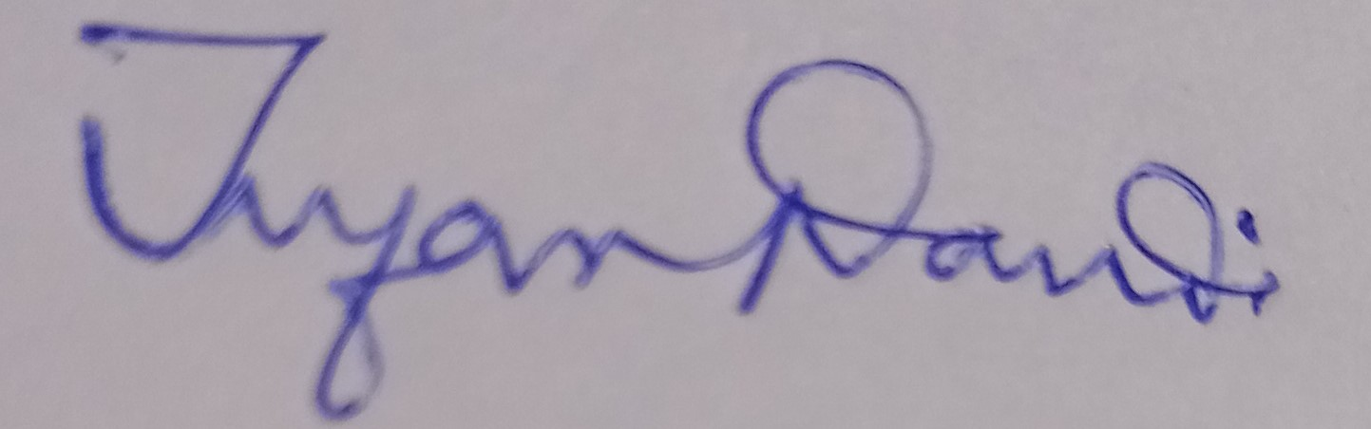
Date- 17/06/2021 Signature

